***“HOTEL MANAGEMENT SYSTEM”***

Mini Project Report

Open Source Technology Lab



Department of Computer Engineering

Ramrao Adik Institute of Technology

Dr. D. Y. Patil Vidyanagar,Sector 7, Nerul, Navi Mumbai 400 706**.**

(Affiliated to University of Mumbai**)**

**April – 2020**

*Index*

|  |  |  |
| --- | --- | --- |
| ***Chapter Number*** | ***Content*** | ***Page Number*** |
| ***1.*** | ***Introduction*** | ***04*** |
| ***2.*** | ***Problem Analysis*** | ***05*** |
| ***3.*** | ***Design*** | ***06*** |
| ***4.*** | ***Result/Output*** | ***08*** |
|  |  |  |

**ABSTRACT**

The software of Hotel Management System which is going to be implemented for Hotel Megastar will automate the major operations of the hotel. The Reservation System is to keep track in rooms and check availability.

The objectives of the automated Hotel Management System is to simplify the day by day processes of the hotel. The system will be able to handle many services to take care of all customers in a quick manner. Safety, easiness of using and most importantly the efficiency of information retrieval are some benefits our team is going to present in this system. The system should be user appropriate, easy to use, provide easy recovery of errors and have an overall end user high subjective satisfaction.

**Chapter 1**

**Introduction**

The Hotel Management System is a new self-contained software product which will be produced by the project team in order to overcome the problems that have occurred due to the current manual system. The newly introduced system will provide an easy access to the system and it will contain user friendly functions with attractive interfaces. The system will give better options for the problem of handling large scale of physical file system, for the errors occurring in calculations and all the other required tasks that has of almost all the tasks done at the Hotel in a much convenient manner. Coding was handled through an Object-oriented approach. Above mentioned methodologies made project work load light and provided the ease of developing.

The main objective of the entire activity is to automate the process of day to day activities of Hotel. Using this system we can manage room activities and keep track of admission of a New Customer. Using this system we can check rooms according to customer’s need and can assign easily room to customer. Checkout of a customer and updating the releasing room information in the system is very easy. When user do checkout system will generate final bill after calculating all the bills. Thus, the Hotel Management System we are going to implement will be covering all the basic processes done in the Hotel. It would handle Guest details, Room booking details, food order, room types and bill generation.

All the above mentioned details and information are stored in the system database. It could save time when retrieving data from the database. Interfaces will be designed user friendly and the functions will be displayed in a simple manner.

Following are the main problem in managing hotel manually

* Manually keeping records is very time consuming.
* Data is not always reliable as it is hand written and some human errors might have occurred example wrong telephone number among other.
* Slow process of reservation. User has find manually whether room is available or not.
* Hotel information data are not secured. It can be easily theft or altered.
* Finding records are very time consuming.
* Retrieval of guest records is extremely difficult. User has to manually search each records to find the required information. It takes lot of time.

The System we are going to develop will give remedies for the problems that are currently facing by our client. Shifting to our system can acquire advantages such as saving of time, man hours, space wastage. This will increase the efficiency in hotel daily activities.

**Chapter 2**

**Problem Analysis**

**Functional Requirements:**

* Add Guest or Register Guest
* Check Room Details
* Check Available Rooms
* Order Food
* Check Guest Details
* Generate Bill

**Non-Functional Requirements:**

Performance Requirements:

* This system should remain accessible 24x7

Security Requirements:

* This system should be accessible only within the hotel premises LAN. Here we are using only LOCALHOST to demonstrate
* The Hotel Management System is accessible only when you have correct credential in terms of username and password.

Software Quality Attributes:

* -----,,,,,,,

Database Requirements:

* SQlite3 and DB SQLite tool

Design Constraints:

* The HMS has to be developed using Python 3.7 and SQLite

**Chapter 3**

**Design**

Explanation :

Product Functions

* Manage Room Details(Add ,Update ,Delete)
* Manage Guest(Add ,Update ,Delete)
* Issue Bills
* Rooms Details
* Food Details
* Guest Information

|  |  |
| --- | --- |
| Function | Add Guest |
| Input | Name, Address, E-mail , Contact No. ,Gender Room types |
| Output | All the Details are inserted in table data in project.sqlite database |
| WorkFlow | Validate the given details and record the information into the database |

|  |  |
| --- | --- |
| Function | Generate Bill |
| Input | Room Number |
| Output | Stay days (Room bill), Food orders(Food bill)  Room Bill, Total Bill |
| WorkFlow | Validate the given details and the total cost is calculated |

|  |  |
| --- | --- |
| Function | Order Food |
| Input | Room Number, Cusine Type, Meal Type |
| Output | All the input along with cost from food table is updated in data table. |
| WorkFlow | Validate the given details and the food cost according to input is calculated |

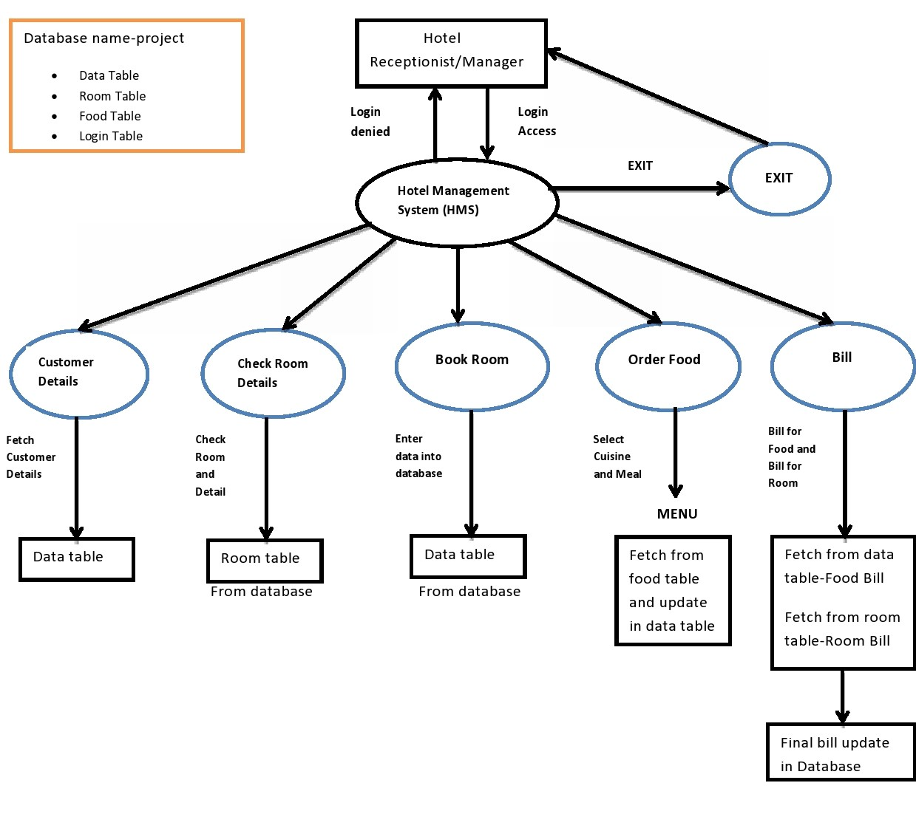

DATAFLOW DIAGRAM

|  |  |
| --- | --- |
| Function | Check availability of Room |
| Input | RoomType |
| Output | Check if room if available or not |
| WorkFlow | Validate the given details and fetch data from room table to check availability of room |

|  |  |
| --- | --- |
| Function | Room details |
| Input | ---- |
| Output | It will output Room number and type of Room |
| WorkFlow | Validate the given details and fetch room number and type from room table |

|  |  |
| --- | --- |
| Function | Guest Details |
| Input | Room Number |
| Output | All the information of guest such as name, gender, contact etc . |
| WorkFlow | Validate the given details and fetch all output data from data table |

**Chapter 4**

**Output/ Results**

Thus we have successfully implemented Hotel Management System in which we can perform various functions like booking,information room, information guests,order food,generate bill Which are demonstrated from following diagrams

Screenshots for GUI:

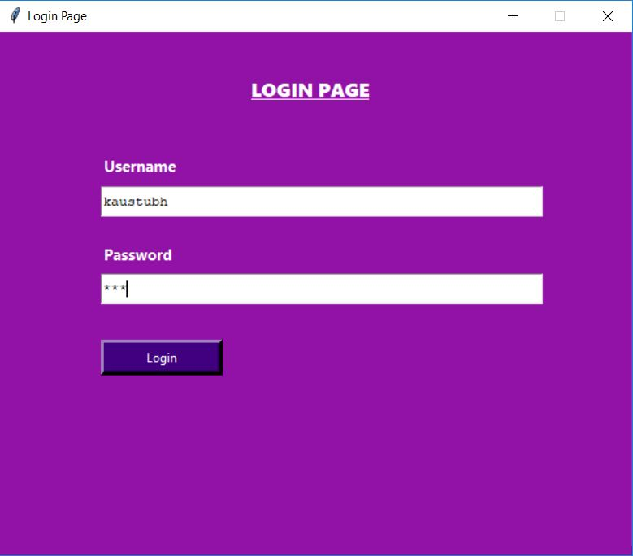 Login Page

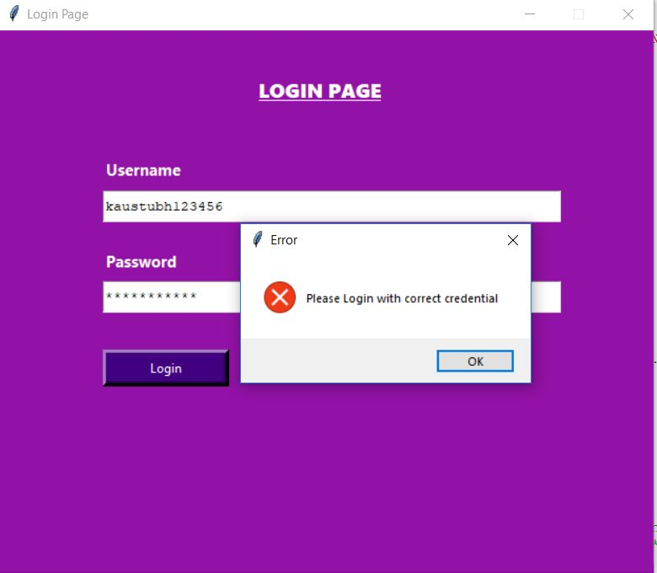

Login Page Error (Invalid credentials)

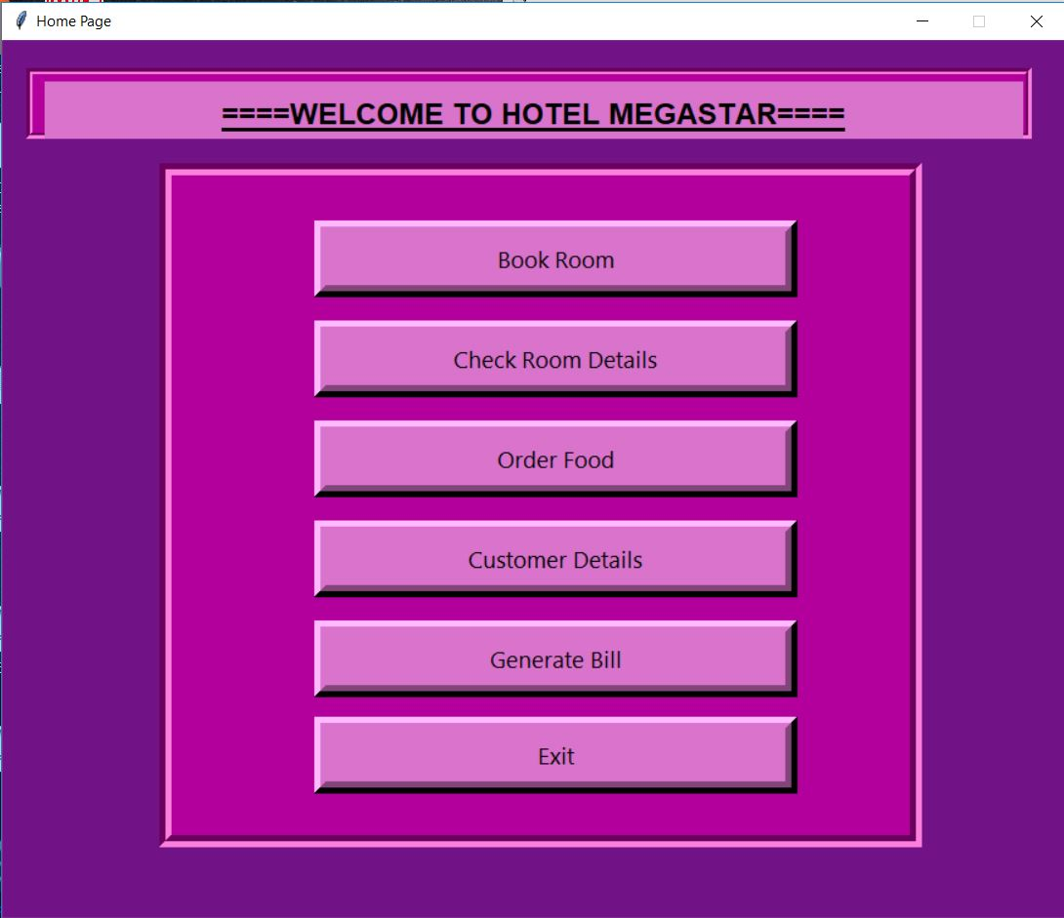

Home Page

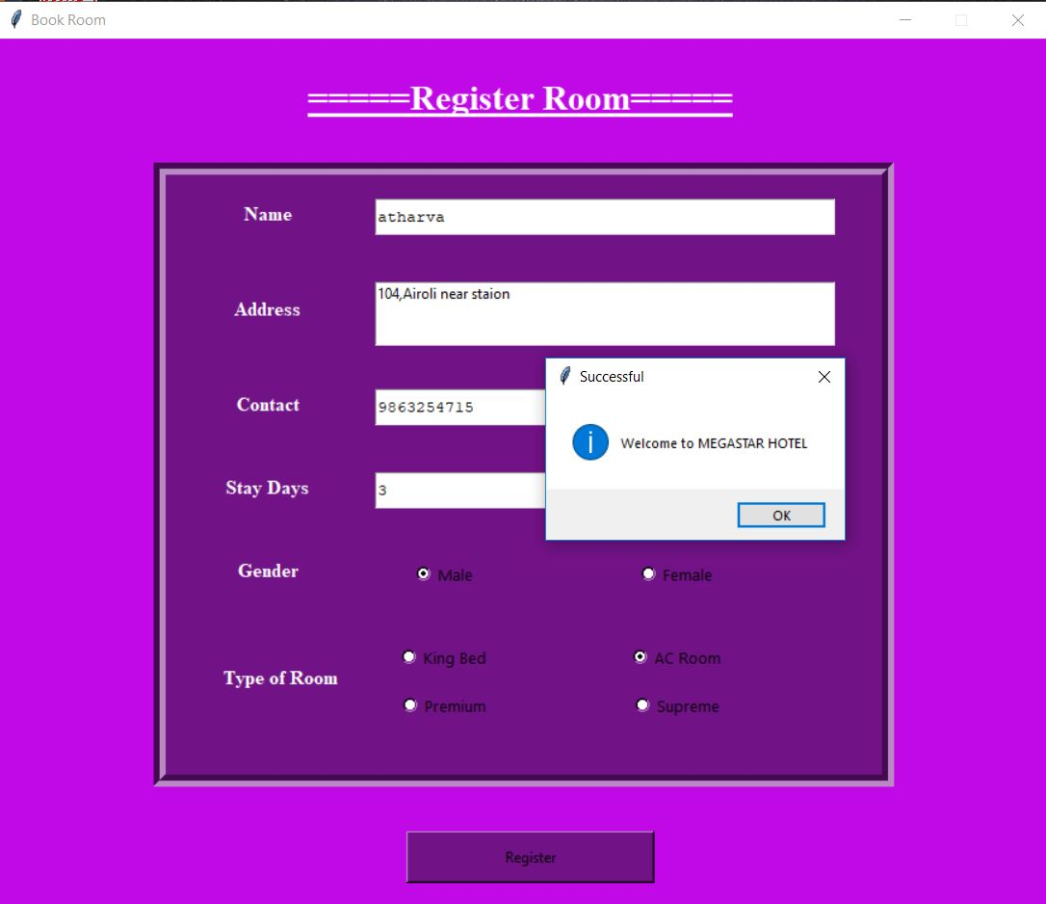

Book Room

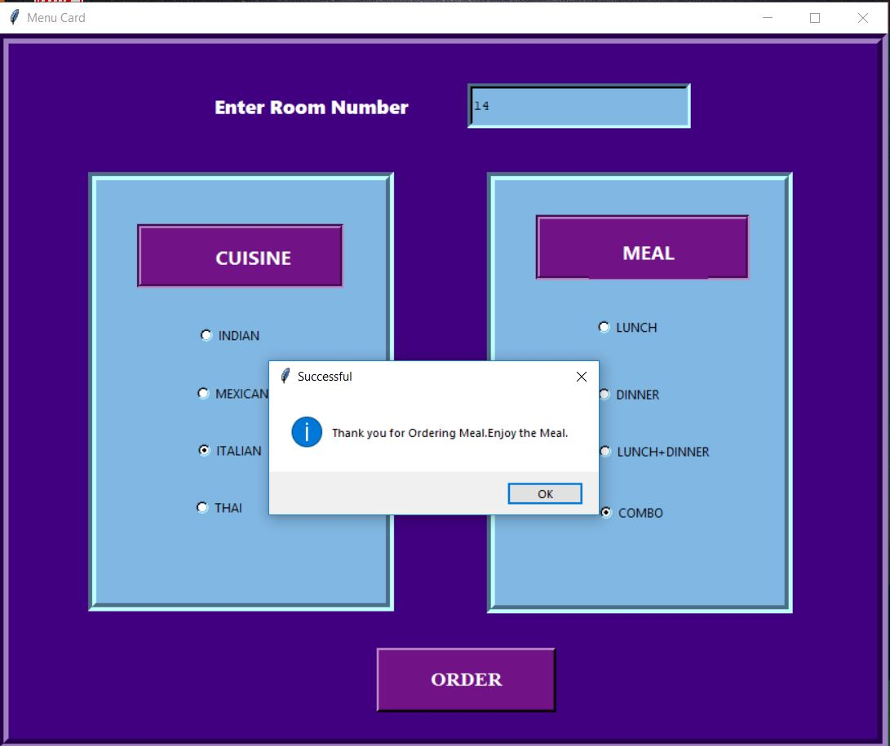

Food Order

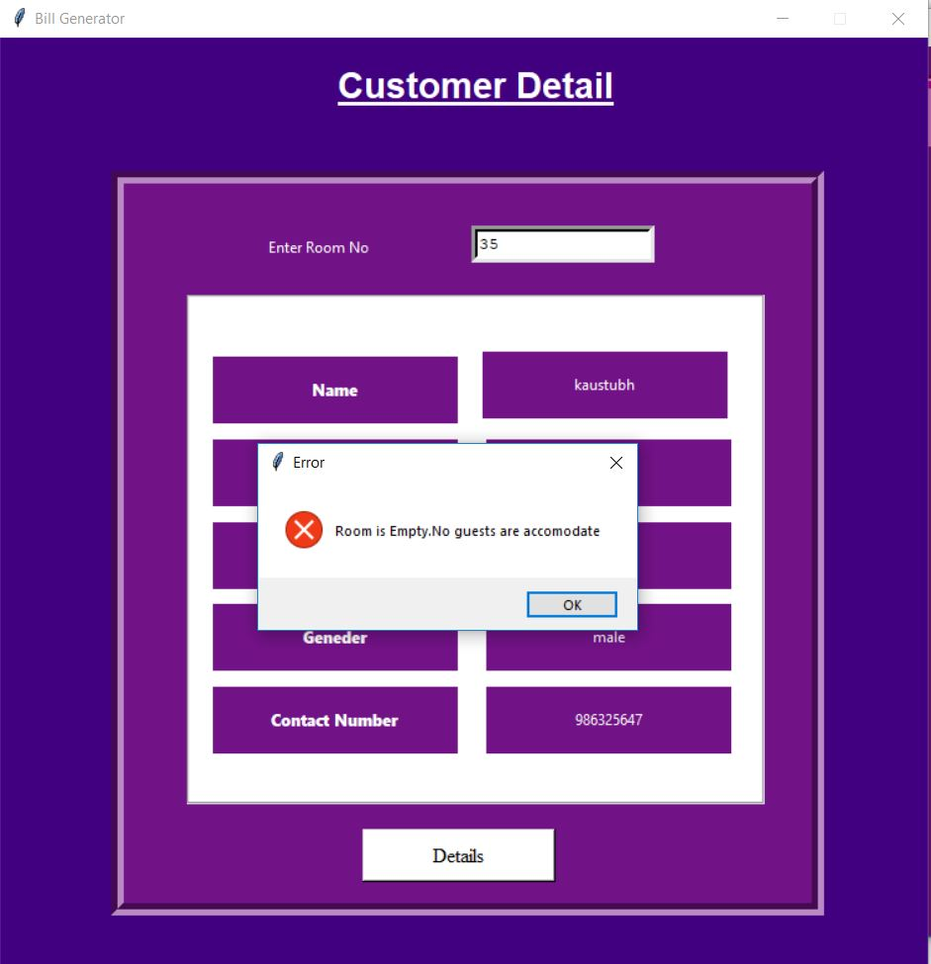 Customer Detail(When Room is not occupied )

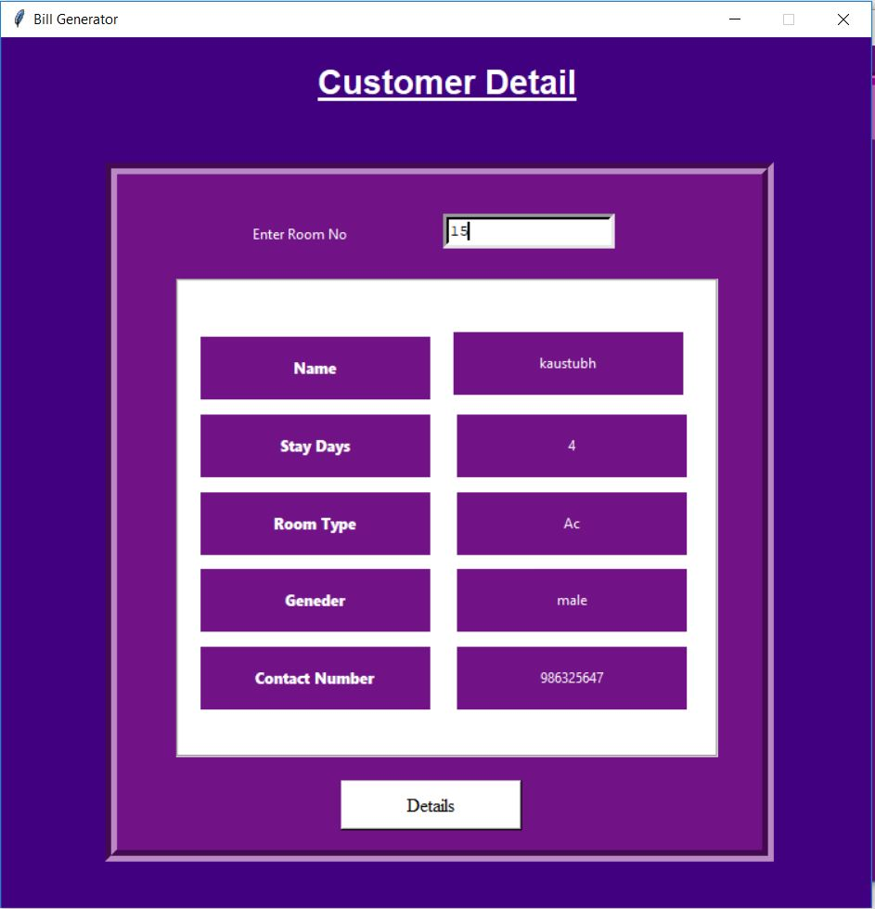

Customer details

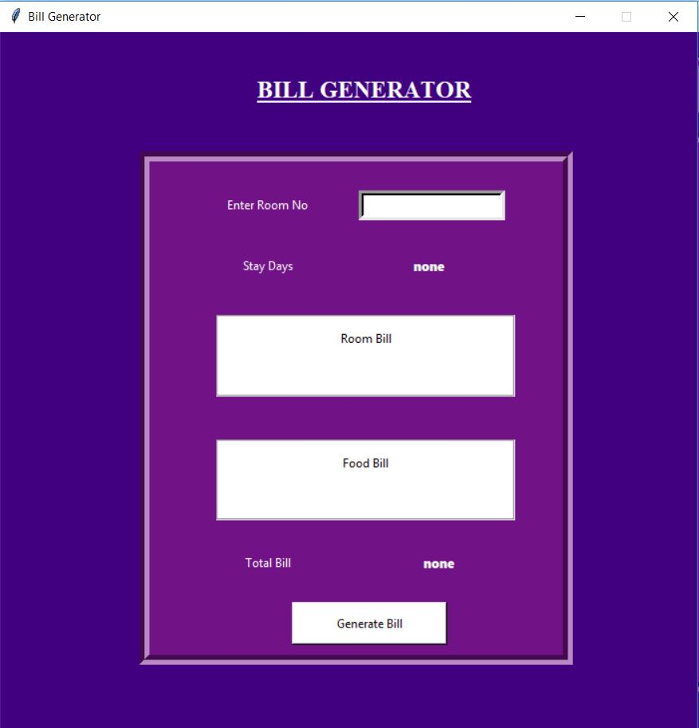

Bill Generation

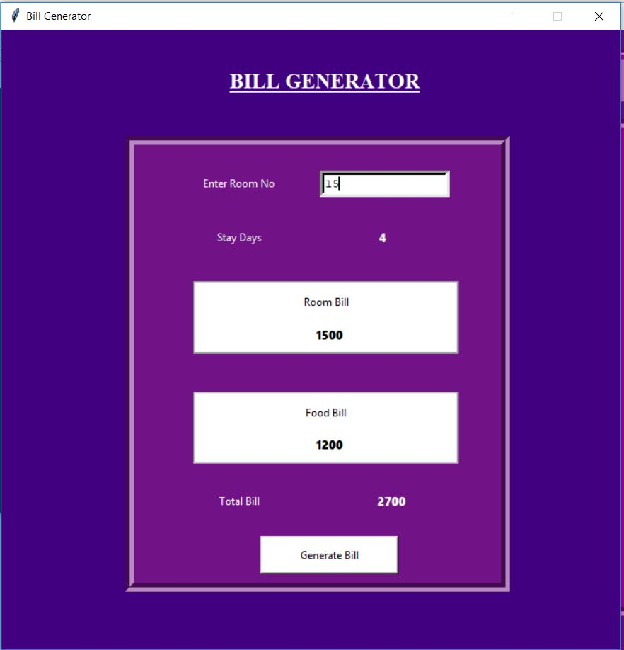

After Bill Generation

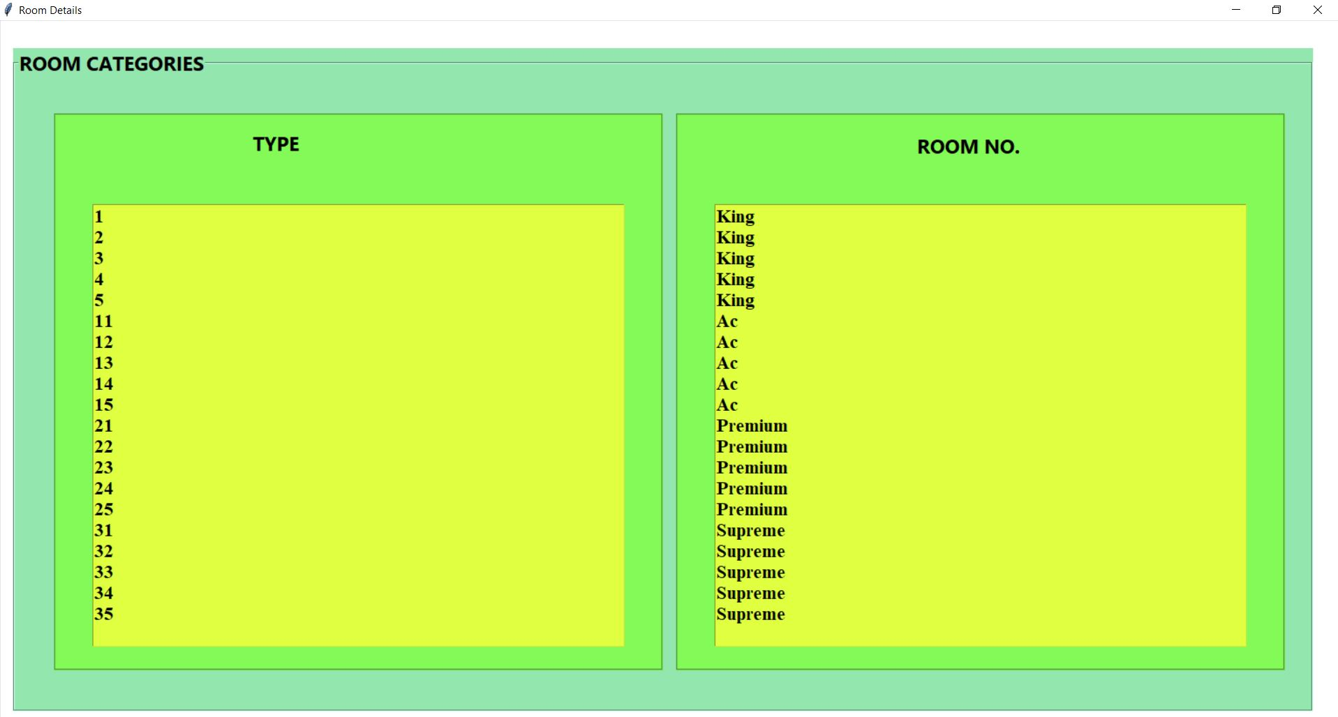Room Details

Screenshots for Database:

